**Sree Siddaganga Education Society (R) (10)**

**SIDDAGANGA INSTITUTE OF TECHNOLOGY**

(An Autonomous Institution Affiliated to Visvesvaraya Technological University-Belagavi, Approved by AICTE, Programmes Accredited by NBA, New Delhi & ISO 9001:2008 Certified)

Tumakuru-572103, Karnataka India



**MINI PROJECT WORK REPORT ON**

**“PROTOTYPE OF MECHANICAL**

**FOOTSTEP POWER GENERATOR”**

In partial fulfilment of the requirements for the VI Semester of Bachelor of Engineering

In Mechanical Engineering

**Submitted By:**

Chitransh Shekhar [1SI18ME024]

Devesh Anand [1SI18ME027]

Kumar Saurav [1SI18ME047]

**Under the Guidance Of:**

“Dr. H R Purushothama, Professor & Head at Department of Mechanical

Engineering Siddaganga Institute of Technology TUMKUR 572103”

**ACADEMIC YEAR 2020-2021**

**Sree Siddaganga Education Society (R)**

**SIDDAGANGA INSTITUTE OF TECHNOLOGY**

(An Autonomous institution Affiliated to Visvesvaraya Technological University-Belagavi, Approved by AICTE, Programmes Accredited by NBA, New Delhi & ISO 9001:2008 Certified)

Tumakuru-572103, Karnataka India

**Department of Mechanical Engineering**



**CERTIFICATE**

This is to certify that the Mini Project work report entitled **“PROTOTYPE OF** **MECHANICAL FOOTSTEP POWER GENERATOR”** is prepared and presented by **Kumar Saurav [1SI18ME047], Devesh Anand [1SI18ME027], Chitransh Shekhar [1SI18ME024]** in partial fulfilment of the requirements for the Third year of Bachelor of Engineering in Mechanical Engineering at Siddaganga Institute of Technology-Tumakuru, during the academic year 2020-2021. The report has been approved as it satisfies the academic requirements for the Bachelor of Engineering Degree. (12)

**Signature of the Guide: Signature of the HOD:**

Dr. H R Purushothama, M.Tech.,

Ph.D. (I.I.T. Madras)

Professor

Dr. H R Purushothama, M.Tech.,

Ph.D. (I.I.T. Madras)

Head of the Department

Name and signature of the Examiners

1. 2.

Dr. H C Madhu

Sri. Ekanthappa J

**ACKNOWLEDGEMENT**

Project of this kind can be triumphed, only by constant guidance and support of many people, involved with it. We are using this as an opportunity to thank all those, without whom, the completion of this project would have been impossible. We thank them for their inspiration, guidance, constructive criticism and friendly advice during the project work.

First and foremost, we wish to offer our sincere gratitude to our guide **Dr. H R Purushothama Sir, Head of the Department, Mechanical Engineering, Siddaganga Institute of Technology, Tumkur** for giving us opportunity to work on this mini project, with him. Without him, the project wouldn’t have even started. Everything was possible because of his kind nature, willingness to always share and teach, time to time counselling and advices. He was always there for providing all the facilities in terms of infrastructure like using workshop facilities and allowing us to proceed further in this project. His technical advices were truly priceless for us and helped us in successful completion of the project.

We thank our beloved **Director Dr. M.N. Channabasappa Sir, CEO Dr. Shivakumaraiah Sir and Principal Dr. S V Dinesh Sir** who are the supporting pillars in every endeavour of ours. They are our constant benefactors who stood by us against all obstacles we faced without any hesitations.

We would also like to thank the coordinator of this mini project **Dr. K Chandrappa Sir, Department of Mechanical Engineering,** for his advices, guidelines and allowing us to apply our knowledge practically and to make something which is could be beneficial for the society.

We would like to thanks all the faculty members of mechanical engineering department for their encouragement time to time.

Last but not least, we would like to thank **all the teaching and non-teaching staff of SIT** and Mechanical department as well as colleagues who helped us either directly or indirectly throughout this project.

Kumar Saurav

Chitransh Shekhar

Devesh Anand

**CONTENTS**

**Particulars** **Page No.**

**Chapter 1 Introduction 06-08**

* 1. Advantages 07

1.2 Basic Principles 07

1.3 Basic components 08

**Chapter 2 Literature 09-11**

2.1 History 09-10

2.2 Methodology 11

**Chapter 3 Design, Fabrication & Analysis Procedure 12-19**

3.1 Procedure 12

3.2 Material Selection 12

3.3 Material Analysis 13-16

3.4 Design Formulas 17-20

**Chapter 4** **Project Work Drawings 21-23**

**Chapter 5** **Results, Discussions and Scope for Future Work 24-25**

5.1 Discussion 24

5.2 Future Scope 24

5.3 Future Work 24

5.4 Cost Estimation 25

**Chapter 6** **References 26**

**SYNOPSIS**

To design and develop, the model of footstep power generation. Also fabricate the model which will work on the systems for required application. The project is related to the box step-up exercise done by athletes and gymnasts during their warm-up sessions. During exercise, one foot should be placed on top of the box, with one on the ground. The weight should be shifted into the heels of your foot that is on the box. Driving through that front heel, while extending the leg completely, the spring is compressed converting stepping motion into rotating motion and then into electrical energy. We are using rack and pinion arrangement directly to rotate the shaft and in second step we are using gear train to obtain better output. Through dynamo the rotational energy is converted into electrical energy. This electrical energy output will be shown by glowing LEDs. The output power is expected to be 12W to 16W in prototype.

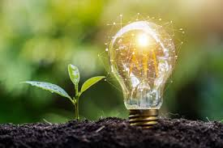

Need of Clean Energy

“The **main aim** of this project is to develop much cleaner cost-effective way of power generation method, which in turns helps to bring down the global warming as well as reduce the power shortages.”

**CHAPTER ONE**

**INTRODUCTION**

Man has needed and used energy at an increasing rate for his sustenance and well-being ever since he came on the earth a few million years ago. Primitive man required energy primarily in the form of food. They derived this by eating plants or animals, which they hunted. With the passage of time, man started to cultivate land for agriculture. They added a new dimension to the use of energy by domesticating and training animals to work for them. With further demand for energy, man began to use the wind for sailing ships and for driving windmills, and the force of falling water to turn water for sailing

ship and for driving windmills, and the force of falling water to turn water wheels. Till this time, it would not be wrong to say that the sun was supplying all the energy needs of man either directly or indirectly and that man was using only renewable sources of energy.

Graph Representing World Energy Consumption & Future Requirements (Ref. 2)

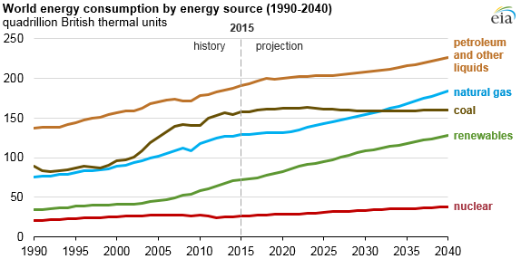

Proposal for the utilization of waste energy of foot power with human locomotion is very much relevant and important for highly populated countries like India where mobility of its masses will turn into boon in generating electricity from its footsteps.

* 1. **Advantages**

“Mechanical Footstep Power Generator” can be implemented for example on railway station, to generate electric power and in all places where movement of people is abundant.

Few of its advantages are:

* This is a non-conventional system
* No need fuel input.
* Power is generated by stepping motion.
* Power also generated by running or exercising on the step.
* Battery is used to store the generated power.
* No pollution content is produced
* It is fully eco friendly
* Easy construction
* It can be used at any time when it necessary
* Highly efficient in more crowded places.
* Depending upon the number of power generators, the power output is very high
* Promising technology for solving power crisis to an affordable extent.
* Reduces transmission losses.
* Wide areas of application.
* Conversion of mechanical energy into electrical energy is easy.
  1. **Basic Principle**

A basic design of foot step power generator is represented in Fig 4.1 of Chapter 4.

When we first step on the upper plate of the model, which in turn attached to four individual spring, four cylindrical rod and two rack.

When the force is applied on the upper plate, the plate and its attached parts move in the downward direction and the rack connected to pinion, starts rotating, which simultaneously rotates the compound gear and then, in turn rotates the small gear, which is connected to the output shaft of the generator.

The whole gear assembly is connected in between the two supporting walls and is supported by a base plate for stability.

* 1. **Basic Components**

1. Base Plate: It is a solid structure which provides support to all the other components.
2. Upper plate: It acts as the load carrier and all other springs and racks are connected to it.
3. Moving Cylindrical Pipe: It supports the spring & prevents from slipping out.
4. Spring: Spring is used to store and release the energy. It is used to return the upper plate to original position by releasing the load.
5. Rack & Pinion: It is used for conversion of the linear motion into the rotational motion.
6. Gears: It is used to transfer motion & torque between different component.
7. Shaft: It is used to mount gear.
8. D.C Generator: It is an electrical machine whose main function is to convert mechanical energy into electricity. When conductor slashes magnetic flux, an emf will be generated based on the electromagnetic induction principle of Faraday's Laws.

**CHAPTER TWO**

**LITERATURE**

* 1. **History**

**“Generation of Electrical Energy from Foot Step Using Rack and Pinion Mechanism” by Md.Azhar, Zitender Rajpurohit, Abdul Saif, Nalla Abhinay, P.Sai Chandu**

In this research paper authors used regulated 5V power, 500mA power supply. Bridge type full wave rectifier is used to rectify the ac output of secondary of 230/12V step down transformer. A rack and pinion is a type of linear actuator including a pair of gears which convert rotational motion into linear motion. The “pinion” engages teeth on the rack. In this paper, since the power generation using foot step get its energy requirements from Non-renewable source of energy. There is no need of power from external sources (mains) and there is less pollution in this source of energy. It is very useful to the places like all roads and as well as all kind of foot step which is used to generate the non-conventional

A Simple Rack & Pinion

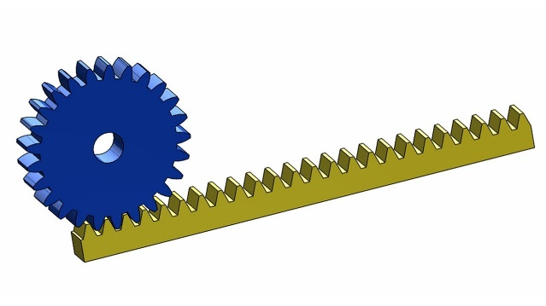

energy like electricity.

**“Electrical Power Generation Using Foot Step for Urban Area Energy Applications” by Joydev Ghosh, Amit Saha, Samir Basak, Supratim Sen**.

In this research paper authors used 80 volts and 40 mA from one coil have been generated from a prototype model as first invention. The second invention provides 95 volts and 50 mA from one coil and this generated power can be used to light LED array and to run DC fan after rectifying the AC or can charge batteries. For high efficiency in the axel of the second gear, they fitted a strong magnet vertically, so that when the gear will rotate due to human body weight the magnet also rotates. The magnet is placed in a loop type copper coil. When the magnet starts rotating, according to the Faraday’s law of electromagnetic induction, there will be induced emf in the coil.

**“Power generation through step” by Vipin Kumar Yadav, Vivek Kumar Yadav, Rajat Kumar, Ajay Yadav**

In these research paper authors used equipment with following specification: Motor Voltage:10-volt Type: D.C. Generator, RPM:1000 rpm, Gear 1-Mild Steel, No. of teeth:59(big gear), No. of teeth:36(small gear), Type: Spur Gear, No. of gear used:2 Spring 1-Load bearing capacity:60-90 kg, Mild Steel, Total displacement:5 inch, bearing 1- Type: Ball bearing, bearing no. N35, Shaft 1-Diameter: 15 mm- Material: Mild steel author concluded that with this method energy conversion is simple efficient and pollution free.

**“Power Generation Footstep” by Shiraz Afzal, Farrukh hafeez**

This paper is all about generating electricity when people walk on the Floor if we are able to design a power generating floor that can produce 100W on just 12 steps, then for 120 steps we can produce 1000 Watt and if we install such type of 100 floors with this system then it can produce 1MegaWattAs a fact only 11% of renewable energy contributes to our primary energy. If this project is deployed, then not only we can overcome the energy crises problem but this also contributes to create a healthy global environmental change. In this project a gear system is attached with flywheel which causes to rotate the dynamo as the tile on the deck is pressed the power that is created is saved in the batteries in addition, we will be able to monitor and control the amount of electricity generated When an individual passes it push the tile on the ground surface which turn the shaft beneath the tile, turn is limited by clutch bearing which is underpinned by holders. Primary shaft is rotate 215approx... Twice by a single tile push. The movement of the prevailing shaft turn the gearbox shaft which builds it 15 times (1:15) then its movement is smoothen by the help of fly wheel which temporary store the movement, which is convey to the DC generator (it generates 12V 40 amp at 1000 rpm).

**2.2 Methodology**

**CHAPTER THREE**

**DESIGN, FABRICATION & ANALYSIS PROCEDURE**

* 1. **Procedure**

The procedure begins by studying the need of requirement of clean energy generation, with most efficiency and least input (converting wasted energy to some useful energy).

The next very important step is selecting the model materials. As the model will go through a lot of pedalling during the process, the material should be selected in such a way that it has a **high endurance limit**, as well as is **cheap & widely available** in market, as this makes the fabrication easy.

Few important properties considered while material selection were **weldability, bending stiffness, bending strength, machinability, spring stiffness**.

Different parts of the whole model, were modelled in the Solid Works software after which, they were assembled and run through various tests and analysis to check for interference. Then the model was put through various load cases to see how much power is generated during the process. With the help of the analysis the model was optimised after several iteration by removing the redundant member and adding supporting member.

* 1. **Material Selection**

The materials used in our project mostly consist of “Mild Steel”. A detailed information is mentioned below:

* The Base Plate 600*300 mm & Upper Plate 600*300 mm is made up of Mild Steel.
* Moving Pipes made up of M.S. Pipes, 20 mm diameter, 115 mm length (115*4)
* Springs are made up of Chrome-vanadium Steel (110*4)
* Shaft is made up of M.S. Pipes, 12 mm diameter,190 mm length (190*2)
* Rack & Pinion, and Gears made up of Cast Iron, Module 2.25
* A DC Motor (Generator) of capacity 12V, 60 RPM

**Why Mild Steel?**

Mild steel (iron containing a small percentage of carbon, strong and tough but not readily tempered), also known as plain-carbon steel and low-carbon steel, is now the most common form of steel because its price is relatively low while it provides material properties that are acceptable for many applications. Mild steel contains approximately 0.05–0.30% carbon making it malleable and ductile. Mild steel has a relatively low tensile strength, but it is cheap and easy to form and surface hardness can be increased through carburizing.

* 1. **Material Analysis**
     1. **Static Structural Analysis of Frame**

**Material Applied:** Mild Steel [5 mm thickness]

**Mesh Size:** 3 mm

**Boundary Condition:**

1. Fixed support at base plate.
2. Spring connection at base plate.
3. Force of 600 N applied on top plate.

Fig 3.3.1.1: Frame (Von Mises Stress)

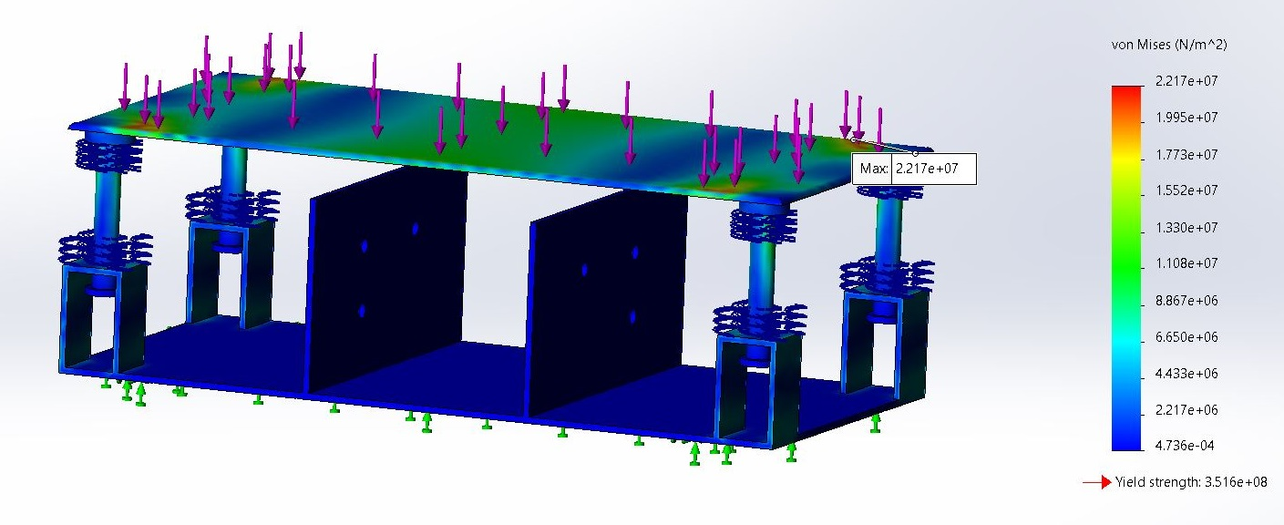

Fig 3.3.1.2: Frame (Displacement)

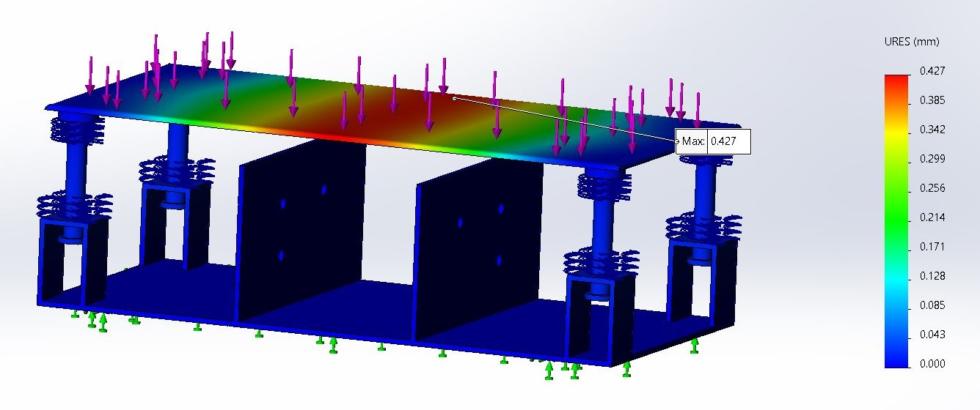

Fig 3.3.1.3: Frame (Strain)

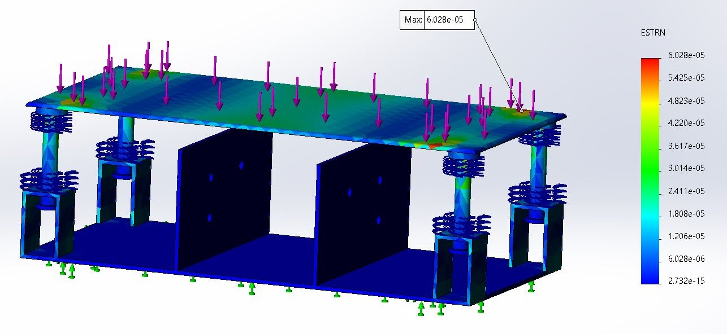

**Result:**

Von Mises Stress: 3.516 x 108 N/mm2

Factor of Safety: 2

As, **Maximum Stress < Yield Stress**

Therefore, **Design is Safe.**

Displacement: 0.427 x 10(-3) m

Strain: 6.028 x 10(-5)

* + 1. **Static Structural Analysis of Gear Assembly**

Both the gear was mated, by specifying the gear ratio & number of teeth to ensure the regular motion of gear.

**The Boundary Condition:**

The large gear was fixed at the shaft hole & the smaller gear was given fixed hinge at the shaft hole. After the torque of 5.0625 N-m was applied on the smaller gear.

Then the mesh control was done & mesh of 3 mm was generated & the study was run.

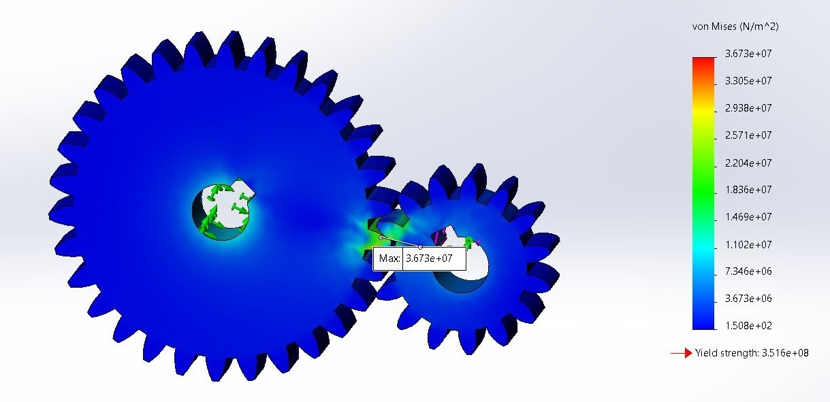

Fig 3.3.2.3: Gear Assembly (Von Mises Stress)

Fig 3.3.2.2: Gear Assembly (Displacement)

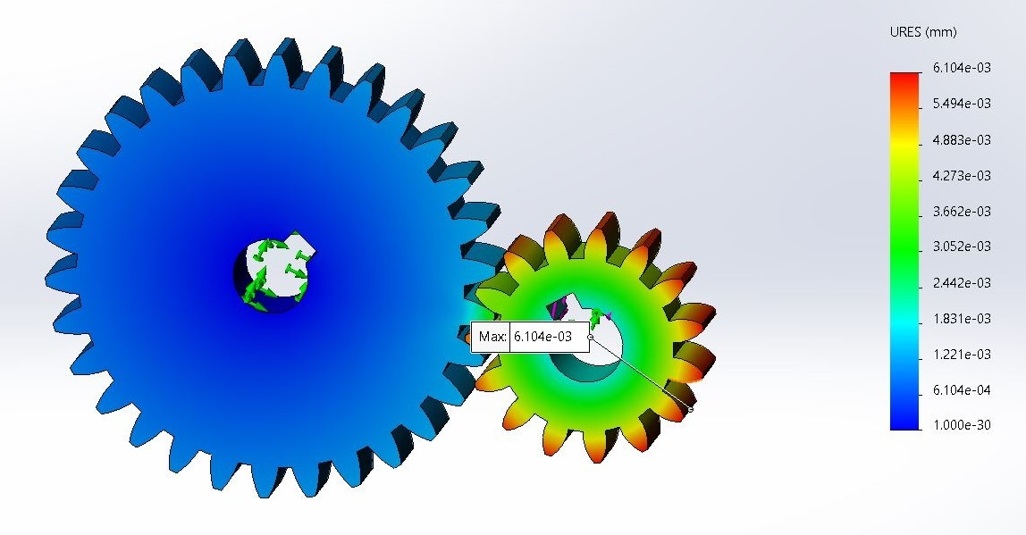

Fig 3.3.2.3: Gear Assembly (Strain)

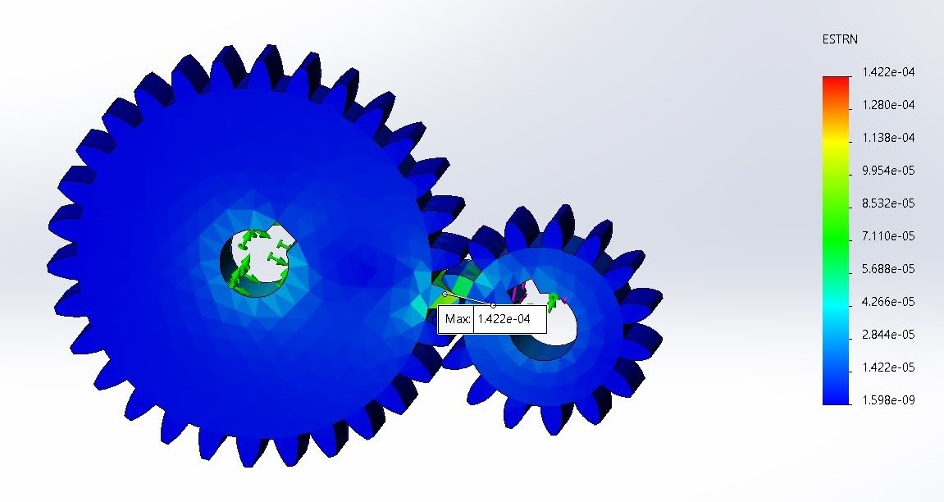

**Result:**

Von Mises Stress: 3.673 x 107 N/m2

As, **Maximum Stress < Yield Stress**

Therefore, **Design is Safe.**

Factor of Safety: 1.48

Displacement: 6.104 x 10(-3) m

Strain: 1.422 x 10(-4)

* 1. **Design:**

**3.4.1 Design of Spring**

The spring being used will be working in a range of **50kg**(490N) to **65kg**(640N). Also, we are going to use springs in each column. Hence the net force on each spring will be in a range of 120N to 160N. Assuming maximum deflection to be 50mm, and Factor of safety = 2.

Assume **Chrome-vanadium steel**

**∴** from Table 20.14

**τ *y*** = ­0.69GPa = 690MPa = 690N/mm2

**G** = 79.34GPa = 79340MPa = 79340N/mm2

**τ** = 345N/mm2

Design the spring for maximum load and maximum deflection

1. **Diameter of wire**

Shear stress τ=  [20.22]

Stress factor K = [20.22]

Spring Index **c**=

∴ 345 =

d = 3.67 ≈ 3.6mm

1. **Diameter of coil**

Mean diameter of coil, D = cd = 10*3.6 = 36mm

Outer diameter of coil, Do = D+d = 36 + 3.6 = 39.6mm

Inner diameter of coil, Di = D-d = 36 – 3.6 = 32.4mm

1. **Numbers of Coil**

[20.22]

i = 11.15

∴ Number of active turns, i = 11

1. **Free Length**

a = 25% of maximum deflection =

Assume plain and ground end

∴ Number of additional Coil, n =

y = maximum deflection y2 = 50mm

∴

1. **Pitch**

***p***=

1. **Stiffness or Rate of Spring**

**Fo**= N/mm

1. **Total Length of Wire**

***l*** = [i’ = i+n = 11+ = 11.5]

=

**3.4.2 Design of Gear**

As per our design, the module of all the selected gear is **2.25**. The gear ration of compound gear and the gear mounted on the output shaft is **2:1**. For Rack & Pinion, the distance travelled by rack per revolution of the pinion is **106.03mm**.

Assuming **Cast Iron**

**σ ≥ 200N/mm2**

Hardness is **less than 223BHN**

1. **Rack & Pinion**

For 106.03mm displacement of rack, pinion will move one revolution.

∴

For 50mm of rack displacement the pinion will move 0.4715 revolution

No. of teeth on pinion is 15.

∴ Pitch diameter = m*t = 2.25*15 = 33.75mm

1. **Compound Gear**

The compound gear are the gears which are mounted on the same shaft, which rotates with the same speed in same direction.

No. of teeth on the compound gear is 30

∴ Pitch diameter = m*t = 2.25*30 = 67.5mm

1. **Output Gear**

This gear will be mounted on the shaft of the generator.

No. of teeth on the output gear is 30

∴ Pitch diameter = m*t = 2.25*15 = 33.75mm

Gear Ratio =

* + 1. **Power Calculation**

The maximum force acting on the upper plate is **640N**

***T***= F*

Maximum deflection of the spring is **50mm**.

The stiffness of the spring is 3.2 N/mm.

The force exerted by ideal spring is given by Hooke’s Law:

(-ve sign because the displacement is in downward direction)

⇒

The energy stored in the spring is given by,

E =

Now, Kinetic energy is given by,

∴ Energy stored in the spring is equal to kinetic spring.

⇒

Now, number of revolution per second is equal to gear ratio of rack and pinion multiplied with the velocity.

**P** = in W

where, **N** – number of revolutions per second (rps)

***T*** - Torque (N-m)

∴ **P** =

* + 1. **Deflection and Power calculation for different load**

|  |  |  |  |  |  |  |  |
| --- | --- | --- | --- | --- | --- | --- | --- |
| **Iteration** | **Mass (kg)** | **Load (N)** | **Deflection (mm)** | **Velocity (m/s)** | **Speed (rps)** | **Torque (N-m)** | **Power (Watts)** |
| **1.** | 50 | 490 | 38.20 | 0.30 | 0.14 | 4.134 | 3.63 |
| **2.** | 55 | 540 | 42.18 | 0.32 | 0.15 | 4.556 | 4.29 |
| **3.** | 60 | 590 | 46.06 | 0.33 | 0.156 | 4.978 | 4.87 |
| **4.** | 65 | 640 | 50.00 | 0.35 | 0.16 | 5.400 | 5.40 |

⇒ The Average power generate will be **4.54** watts.

Theoretical Stress,

**CHAPTER FOUR**

**PROJECT WORK DRAWINGS**

8.Rack

7.Pinion

4.Base Plate

3.Moving Pipe

6.Shaft

5.Gear

2.Spring

1.Upper Plate

Fig 4.1: Wire Frame View [Assembly]

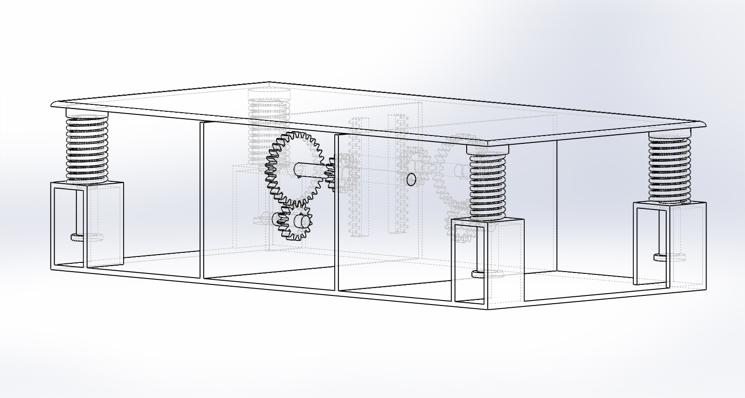

Fig 4.2: Assembled View Mechanical Footstep Power Generator

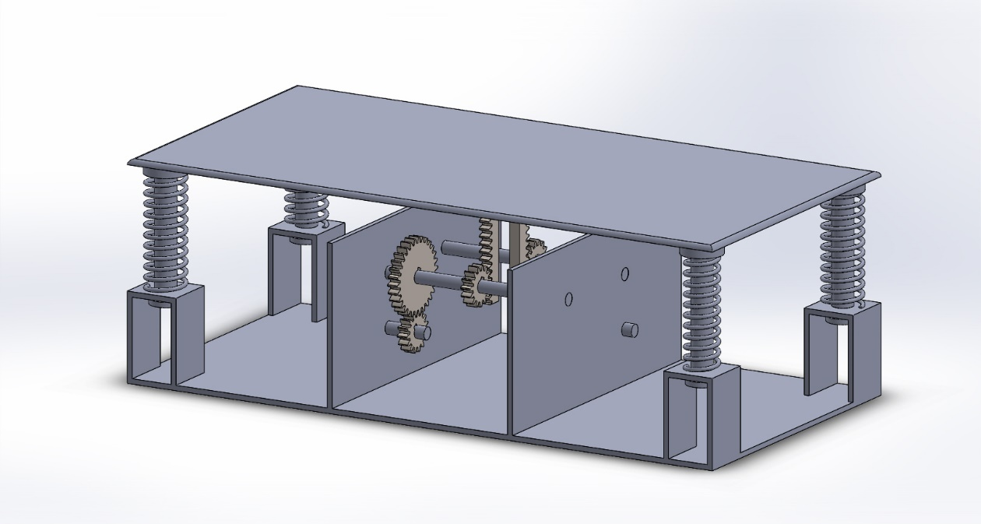

Fig 4.2.1: Gear Assembly

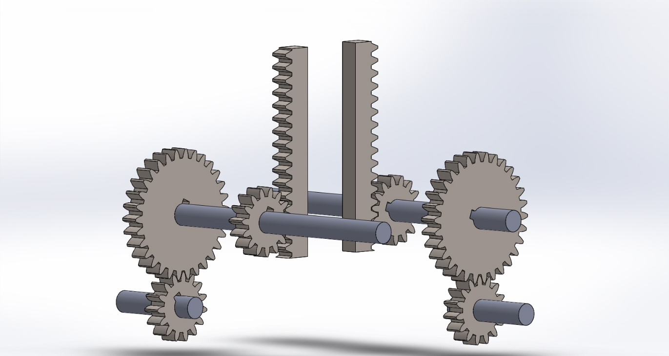

Fig 4.2.2: Moving Cylindrical Shaft

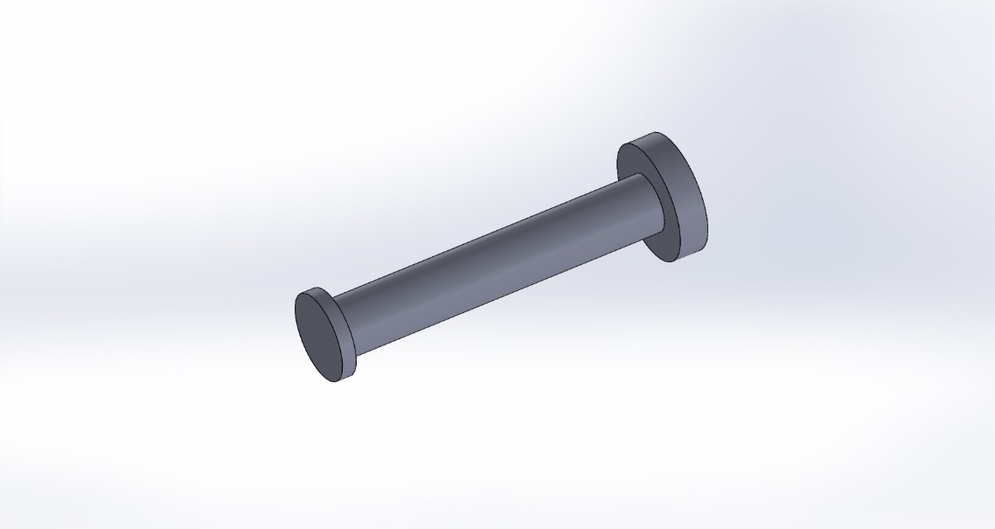

Fig 4.2.3: Spring

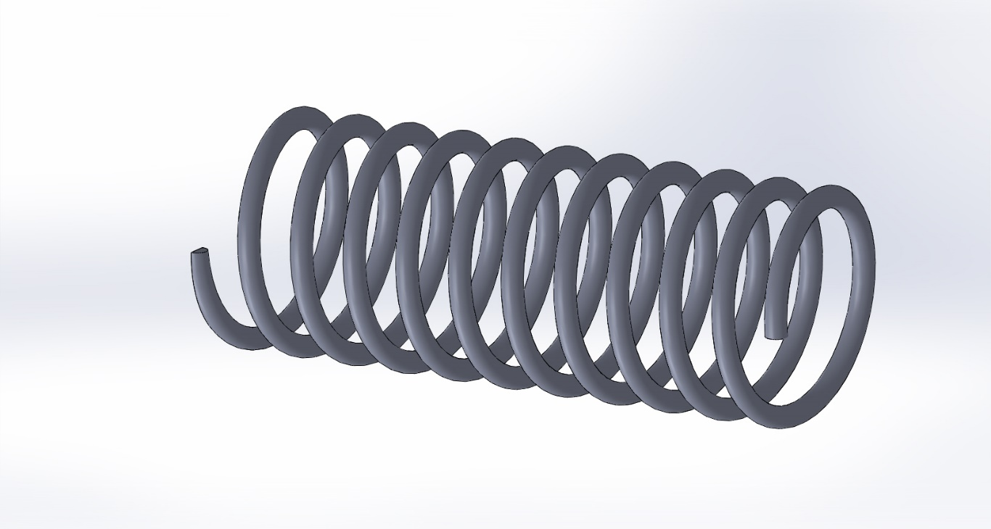

Fig 4.2.4: Base Plate

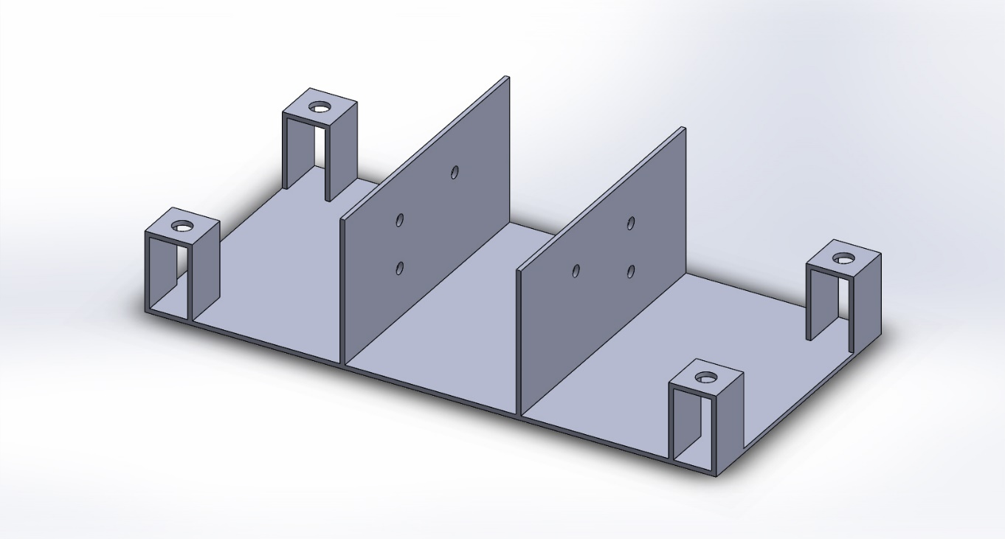

**CHAPTER FIVE**

**RESULTS, DISCUSSIONS AND SCOPE FOR FUTURE WORK**

**5.0 Result & Discussion**

1. **Discussion**

Since in this project of power generation, there is no type fuel input requirement for the generation of electrical power. Thus, it can also be concluded that this mode of power generation system is eco-friendly, i.e., no pollution is caused during the generation of power using this type of model. Hence due to such advantages, this system can be embedded at any of the public places like railway platforms, busy foot-paths, malls etc. Implementing this system, we can easily reduce our dependency on the conventional sources of energy, thus can be considered beneficial from that point of view.

Eco -Friendly

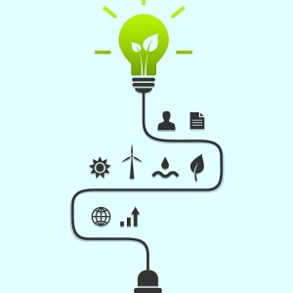

1. **Future Scope**

The project work “Power generation by foot step” is designed and developed successfully for the demonstration purpose. A prototype module is constructed considering an actual model & results are found.

Box Step-Up Exercise

1. **Future Implementations**

This can be implemented on railway station to generate electric power and in all places where movement of people is abundant. Places like Gym, hospitals,etc are all over crowded and millions of people move round the clock. As a result, large amount of power can be obtained with the use of this promising technology.

* Exercises equipment
* Temples
* Bus stands, air ports
* Music halls, auditoriums
* Markets
* Hospital
* In car parking system.
* In Airports.
* Health Centre

1. **Cost Estimation**

|  |  |  |  |
| --- | --- | --- | --- |
| **Sl. No.** | **Components** | **Details** | **Cost (in ₹)** |
|  | Base Plate & Upper Plate | Mild Steel, 600 * 300 mm [Base Plate], 600*300 mm [Upper Plate] | 1,000 |
|  | Shaft | M.S. Pipes, 12 mm diameter,190 mm length (190*2) | 300 |
|  | Moving Cylindrical Pipes | M.S. Pipes, 20 mm diameter, 115 mm length (115*4) | 400 |
|  | Springs | Chrome-vanadium steel, wire diameter 3.6 mm (110*4) | 600 |
|  | Rack & Pinion, Gear | Cast Iron, Module 2.25 | 1,400 |
|  | DC Generator | 12V, 60 RPM | 250 |
|  | Fabrication | Cutting, Welding, etc | 600 |
|  | Assembly | Mounting, Adjusting rack & pinion etc, & final welding | 500 |
| **Roughly Estimated Cost is around ₹ 5,000 to ₹ 5,500** | | | |

**CHAPTER SIX**

**REFERENCES**

1. Mechanical Footstep Power Generation, India International Journal of Engineering Trends and Applications (IJETA) – Volume 5 Issue 2, Mar-Apr 2018
2. Design of Machine Elements 1 and 2, by Das J.B.K. Sapna Book Publication, First Edition.
3. All the design values have been referred from Machine Design Data Handbook, Volume 1 - Second Edition, Suma Publications
4. https://www.wikipedia.org
5. https://byjus.com/physics/dc-generator
6. <https://my.solidworks.com/solidworks/guide/SOLIDWORKS_Introduction_EN.pdf>
7. https://www.koyo.com.br/upload/koyo/cat203ex%20%20Ball%20&%20Roller%20Bearings.pdf
8. https://www.google.co.in/imghp?hl=en&authuser=0&ogbl